
Handraiser Service Interface for vw.com
March, 2011
V9

Table of Contents
1. INTRODUCTION 3
2. HANDRAISER PROSPECT XML DATA FORMAT 3
2.1. Web Application URL 6
2.2. Web Application Response 6
2.2.1. Success Condition 6
2.2.2. Error Condition 6
3. APPENDIX 7
3.1. XML Schema Document 7
3.2. Example: Minimal Prospect Information 7
3.3. Example: Prospect Information Superset 7
3.4. Model values: 7

INTRODUCTION
This document provides interface details for sending handraiser lead prospect data to vw.com from user interface components running inside web browsers.

In order to store handraiser prospect information, vw.com utilizes a global customer relationship management (CRM) database operated by Volkswagen AG in Germany. The global CRM system is called KuBa. A web service in vw.com captures handraiser prospect information and sends it to KuBa. A simplified diagram of the system is shown below.

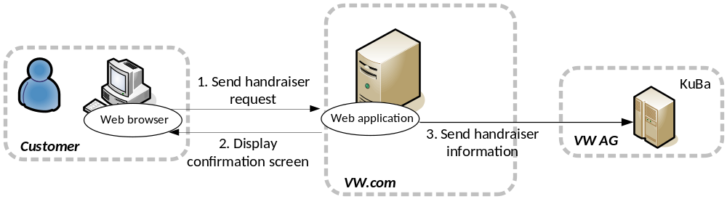
Figure 1 Handraiser prospect information data flow

The web browser sends prospect information over HTTP protocol as XML data. The web application parses XML data, stores it in database and then sends it to KuBa. In this document, we describe the required XML data format for handraiser prospect information to be submitted from web browsers.

HANDRAISER PROSPECT XML DATA FORMAT
The APPENDIX gives XML schema document for handraiser prospect XML data format. It can be seen that most elements are optional. The following elements are designated as mandatory:
- handraiser/campaignID This is unique campaign identifier and associates the handraiser data with a specific campaign in KuBa. Normally, this is going to be a hidden field in the HTML form hosted in campaign specific micro site in vw.com.
- handraiser/contact/firstName This is first name of the customer. This field should not be used to capture full name of the customer.
- handraiser/contact/lastName This is lastname of the customer
- handraiser/address/zip This is zipcode of the customer
- handraiser/desiredCar/model (See section 3.4 for valid model values)
- Method of Communication: At least one method of communication is required, either email, phone or complete mailing address (address, city, state & zip).

Example below (see Example: Minimal Prospect Information) is a sample handraiser XML document that is submitted from a web browser to vw.com and contains only mandatory fields:
<?xml version="1.0" encoding="UTF-8"?>
<!--Minimal form data-->
<handraiser>
<campaignID>5</campaignID>
<contact>
<firstName>John</firstName>
<lastName>Doe</lastName>
<email>john.doe@test.net</email>
<address>
<zip>48335</zip>
</address>
</contact>
<desiredCar>
<model>VW0000</model>
</desiredCar>
</handraiser>

Example below (Example: Prospect Information Superset) is a sample handraiser XML document that is submitted from a web browser to vw.com and contains all fields mentioned in the schema. Note that SurveyID should correspond to an id configured in the database for the particularcampaign, identified with campaignID, ahead of time. Valid campaignID and SurveyID values can be requested from VWMROSupport@Compuware.com.

<?xml version="1.0" encoding="UTF-8"?>
<!--Superset form data-->
<handraiser>
<campaignID>USVW-CE-11TSTSRVY</campaignID>
<contact>
<title>0001</title>
<firstName>John</firstName>
<lastName>Doe</lastName>
<language>EN</language>
<email>john.doe@test.net</email>
<phone preferred="true">1234567890</phone>
<mobile preferred="false">3334445555</mobile>
<address>
<street1>123 State Street</street1>
<street2>Apt. 1</street2>
<city>Detroit</city>
<state>MI</state>
<zip>48226</zip>
<country>US</country>
</address>
</contact>
<desiredCar>
<model>VW0000</model>
<engineVersion>A</engineVersion>
<enginePower>150</enginePower>
<transmissionType>0001</transmissionType>
<plannedPurchaseDate>2009-08-13</plannedPurchaseDate>
<typeOfPurchase>0001</typeOfPurchase>
<plannedUsage>0001</plannedUsage>
<plannedFinancingType>0001</plannedFinancingType>
</desiredCar>
<desiredCar>
<model>VW0101</model>
<engineVersion>A</engineVersion>
<enginePower>150</enginePower>
<transmissionType>0001</transmissionType>
<plannedPurchaseDate>2009-08-13</plannedPurchaseDate>
<typeOfPurchase>0001</typeOfPurchase>
<plannedUsage>0001</plannedUsage>
<plannedFinancingType>0001</plannedFinancingType>
</desiredCar>
<currentCar>
<brand>AU</brand>
<model>4A</model>
<modelYear>2001</modelYear>
<mileage>110000</mileage>
<purchaseDate>2001-03-13</purchaseDate>
<registrationDate>2001-03-13</registrationDate>
<usage>0001</usage>
<financingType>0001</financingType>
<endOfFinancingDate>2006-03-13</endOfFinancingDate>
</currentCar>
<survey>
<SurveyID>1</SurveyID>
<SurveyItems>
<SurveyItem>
<Question>q1_intrigue</Question>
<Answer>a1o2_price</Answer>
</SurveyItem>
<SurveyItem>
<Question>q2_when_pur_veh</Question>
<Answer>a2o4_3_6_mths</Answer>
</SurveyItem>
<SurveyItem>
<Question>q3_pur_or_lse</Question>
<Answer>a3o1_purchase</Answer>
</SurveyItem>
<SurveyItem>
<Question>q4_trade_in</Question>
<Answer>a4_trade_in</Answer>
</SurveyItem>
<SurveyItem>
<Question>q5_next_veh_typ</Question>
<Answer>52o1_new</Answer>
</SurveyItem>
<SurveyItem>
<Question>q_desi_vehicle</Question>
<Answer>VW0201_VW0202</Answer>
</SurveyItem>
<SurveyItem>
<Question>q7_cntc_by_dlr</Question>
<Answer>a7_cntc_by_dlr</Answer>
</SurveyItem>
</SurveyItems>
</survey>
<links>
<linkId1>link 1 test</linkId1>
<linkId2>link 2 test</linkId2>
<linkId3>link 3 test</linkId3>
</links>
<BPID>ID000001</BPID>
</handraiser>

Note that values of the following elements are restricted to their respective sets of admissible values; see the annotations in XML schema document for details.
- handraiser/contact/title
- handraiser/contact/phone
- handraiser/contact/mobile
- handraiser/desiredCar/engineVersion
- handraiser/desiredCar/transmissionType
- handraiser/desiredCar/typeOfPurchase
- handraiser/desiredCar/plannedUsage
- handraiser/desiredCar/plannedFinancingType
- handraiser/currentCar/usage
- handraiser/currentCar/financingType

In particular, values for the phone and the mobile should be 10-digit and numeric. For example, the following is a valid number:
- 1112223333

However, the following are invalid numbers:
- 111-222-3333
- 2223333
- (111) 222-3333

The following elements are restricted in value. Send email to VWMROSupport@Compuware.com to get current values.
- handraiser/currentCar/brand
- handraiser/currentCar/model

Currently, the fields linkId1, linkId2, linkId3 are for future use only. They are captured and stored in database, however, they are not sent to KuBa.

Web Application URL
Web browser should submit handraiser prospect data as follows:

Production:
http://servicesvw.vw.com/handraiser/ProcessHandraiser.do?xml=<DATA>

Staging Environment:
http://stage.vw.com/handraiser/ProcessHandraiser.do?xml=<DATA>

where <DATA> is an XML string compliant with the XML schema discussed above. Both GET and POST are supported.

Web Application Response

Success Condition
Upon successfully receiving, parsing and saving handraiser prospect data, the web application will return HTTP 200 along with the following response:

<?xml version="1.0" encoding="UTF-8" ?>
<handraiser>
<request-id>REQUESTID </request-id>
</handraiser>

where REQUESTID is a long integer that represents ID of the newly created handraiser prospect in vw.com database. As an example, see below.

<?xml version="1.0" encoding="UTF-8" ?>
<handraiser>
<request-id>5000</request-id>
</handraiser>

The REQUESTID is useful for troubleshooting activity and is not intended for displaying to customer.

Error Condition
In case of failure due to parsing or saving of handraiser prospect data, the web application will return HTTP 200 along with the following response:

<?xml version="1.0" encoding="UTF-8"?>
<error>
< message >ERRORDESCRIPTION</ message >
<errorCode> ERRORCODE </errorCode>

</ error>

where ERRORDESCRIPTION is text describing the particular error and value of ERRORCODE will be 3.

APPENDIX
This section gives the XML schema document associated with the handraiser prospect information and various examples.

XML Schema Document
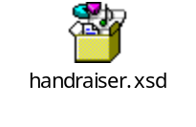

Example: Minimal Prospect Information

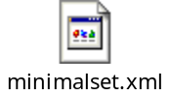

Example: Prospect Information Superset

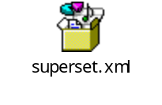

Model values:

+--------+------------------------+
| Model | Description |
+--------+------------------------+
| VW0000 | Volkswagen |
| VW0101 | VW Jetta |
| VW0201 | VW Passat |
| VW0301 | VW GLI |
| VW0401 | VW CC |
| VW0501 | VW New Beetle |
| VW0601 | VW Eos |
| VW0701 | VW Tiguan |
| VW0801 | VW Touareg 2 |
| VW0901 | VW Routan |
| VW1001 | VW GTI |
| VW1201 | VW Rabbit |
| VW1301 | VW Jetta SportWagen |
| VW0202 | Passat Sedan |
| VW0203 | Passat Wagon |
| VW0502 | New Beetle Convertible |
| VW1401 | Golf |
+--------+------------------------+

